Company Background (Tempo Scan PT)
Tempo Scan Pacific was first established back in 20 May 1970, under its original name PT Scanchemie and has grown in operations until today to become one of the leading sales and distribution companies in Indonesia. It currently distributes for both multi-national and local companies, with products ranging from pharmaceutical & consumer health, cosmetics & personal care, household cleaning, infant formula and beverages.
It's sales and distribution network is widespread throughout the whole Indonesian areas, which allows Tempo to reach its customers quickly and efficiently. It should be noted that this is a key factor that has helped Tempo and its business partners to achieve outstanding sales growths over the past several years.
Tempo's sales force performs direct sales coverage to almost all outlet types, ranging from pharmacies, hospitals, institutions, supermarket chain and independent stores, drugstores, wholesale and retail outlets, and a direct coverage of doctors for its vaccine products. It also has sales force groups dedicated to specific trade segments, allowing it to focus more on the types of products being sold in a particular channel of distribution.
Tempo's services to the trade aside from sales coverage includes: a credit facility, customer service personnel in every sales branch, and a delivery group of motorcycles and trucks sufficient to serve the orders of all customers.
Furthermore, for its business partners; Tempo also provides account management services specifically in the areas of business analysis, inventory management, central warehousing and trade promotion planning and execution.
In terms of information technology (I.T.), Tempo started to operate on SAP since January 2003 - the source of all sales information which is found in this website.
Overall, it has more than 50 years of experience, characterized by consistent sales growth year after year, an ever expanding customer base, and a growing variety of products. All these, backed up with a solid financial foundation, which is what we are hoping to find in this financial analysis report.

Citation
Tempo Scan PT. (n.d.). About Us. Retrieved 12 13, 2010, from Tempo Scan PT: https://www.pttempo.com/AboutUs.aspx

Subsidiaries
Subsidiaries owned by TPSC are as followed: (Data, as of 2010)
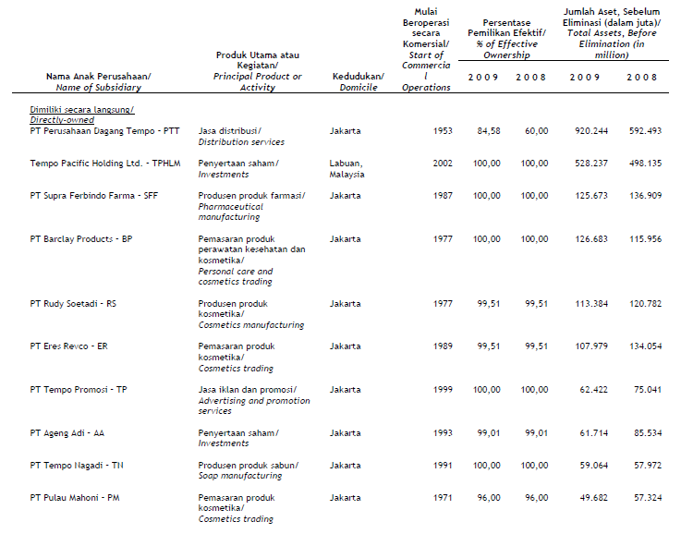
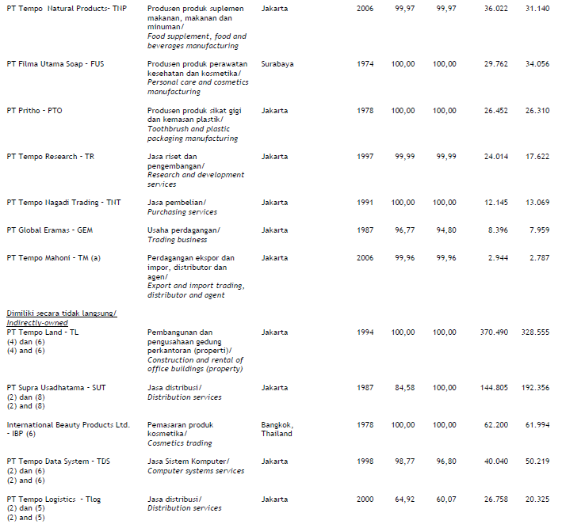
Investment Activities
Current Asset
Current assets are assets which can be converted to cash, usually within the operating cycle. It is important to understand Current Asset because it will later be used on the important subject of liquidity, and show to investor it can survive in the short run.
The Total Current Assets for TPSC are as followed:
 | 2007 | 2008 | 2009
Current Assets | 1,863,931,039,383 | 2,055,154,829,880 | 2,354,076,614,325

On the surface, we can see it has increase year by year. This is considered okay, since it is what should be normally expected for normal running business.
Cash and Cash Equivalent
Cash is the most liquid current asset, as it can be used to pay short term obligations directly.
 | 2007 | 2008 | 2009
Cash on Hand | 3,229,580,029 | 2,182,230,273 | 2,076,675,106
Cash in Banks
# IDR | 10,382,933,822 | 8,952,587,463 | 12,160,245,275
# USD | 3,310,255,746 | 12,055,533,888 | 3,414,583,359
# Euro | 337,792,697 | 463,088,643 | 713,461,547
# SGD | 401,211,216 | 347,258,646 | 546,445,903
# Thailand Baht | 318,219,596 | 6,436,130,409 | 101,553,518
# Philippine Peso |  | 1,059,561,761 | 593,622,133
# Australian Dollar |  |  | 22,299,608
Total Cash in Banks | 14,750,413,077 | 29,314,160,810 | 17,552,211,343
Cash Equivalent
# IDR | 107,459,000,000 | 383,218,000,000 | 800,972,000,000
# USD | 160,685,582,081 | 230,863,509,116 | 200,464,400,000
# Euro | 107,573,427,076 | 155,398,749,682 | 150,160,204,350
# Thailand Baht | 15,765,102,960 | 16,941,545,143 | 9,505,123,371
# Certificates of Bank Indonesia | 542,529,266,184 | 190,334,380,473
Total Cash Equivalents | 934,012,378,301 | 976,756,184,414 | 1,161,101,727,721
Total Cash and Cash Equivalents | 951,992,371,407 | 1,008,252,575,497 | 1,180,730,614,170

As we can see, if we look at the cash on hand, the amount is decreasing year by year. However, if we look at the total cash and cash equivalents; we can see that the amount is increasing. This could suggest cash is flowing more from international activities, and that more cash is used to invest outside.
To see a bigger picture, we would have to look at it as a percentage of the total asset.
2007 | 2008 | 2009
34.33% | 33.98% | 36.18%

When we compare cash and cash equivalent as a percentage of total assets it does not have significant changes between three years. This indicates that the company did improve their performance in terms of cash flow, but not in that significant amount. Also, cash and cash equivalent as a percentage of total assets of more than 25% indicate that one fourth of the company’s assets are highly liquid. When we look through the competitor, Indofarma, they have the lower percentage of cash flow which is 15% and Kalbefarma, which shows a percentage of 24%. Consequently, we can conclude that TPSC performs better than its competitor in terms of cash control.
Account Receivable
Back to the main concept of liquidity, if we talk about another important component of current assets is account receivable. The amount in the balance sheet is already subtracted the allowance for bad debt.
 | 2007 | 2008 | 2009
Trade Receivables
# Third Parties
## Domestic | 297,148,924,187 | 332,406,557,999 | 455,602,693,835
## International | 22,531,887,834 | 38,989,153,789 | 8,453,546,242
# Related Parties
## PT Kendaga Isi Mulia | 2,082,606,073 | 1,002,680,334 | 296,582,693
## Others | 746,988,995 | 173,134,646 | 274,891,420
Total Trade Receivables | 322,510,407,089 | 372,571,526,768 | 464,627,714,190
Other Receivables
# Third Parties | 10,037,824,009 | 17,324,261,077 | 17,105,853,926
# Related Parties | 12,315,390,378 | 1,262,802,836 | 632,258,426
Total Other Receivables | 22,353,214,387 | 18,587,063,913 | 17,738,112,352
Total Receivables | 344,863,621,476 | 391,158,590,681 | 482,365,826,542

The increase in account receivable might because of the increase in sales, and at the same time, they made more transactions using account receivables rather than cash transactions. Hence, explain why there was less cash on hand in later periods.
We could also refer back to the financial statement to get more detailed explanation of the A/R.
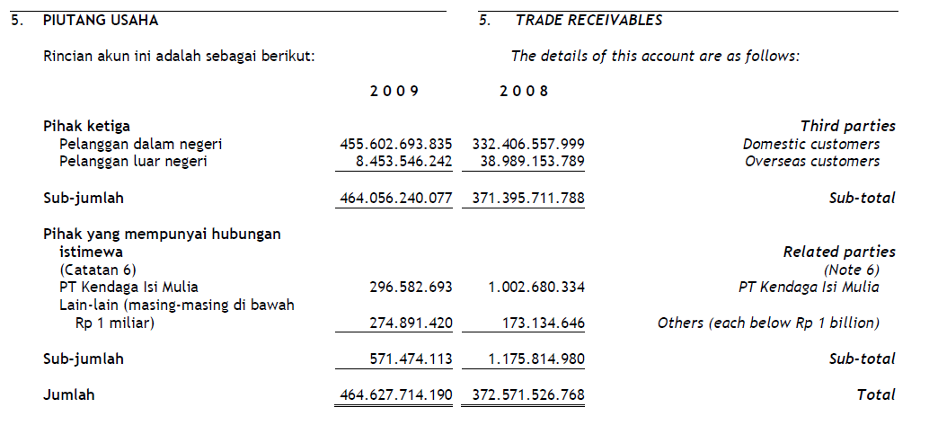
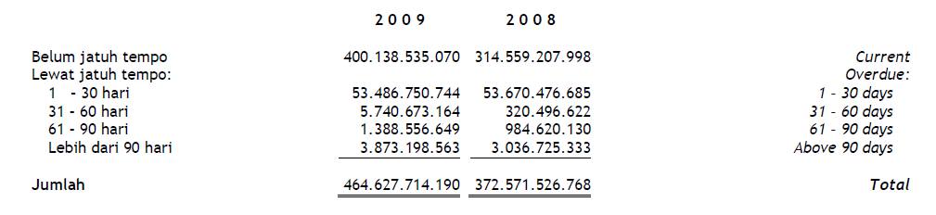

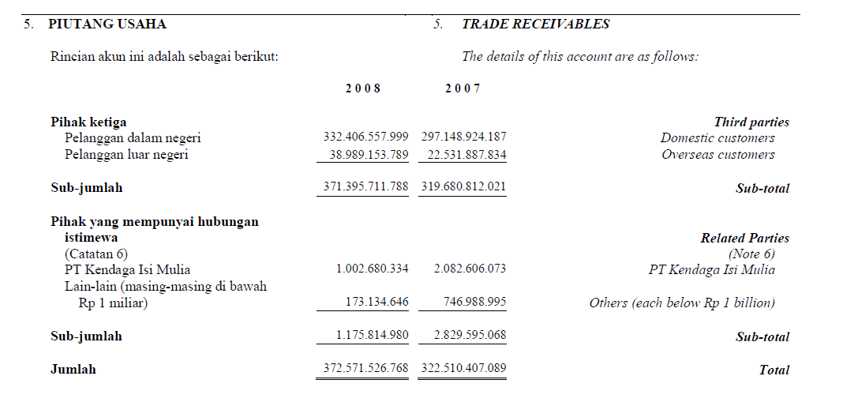
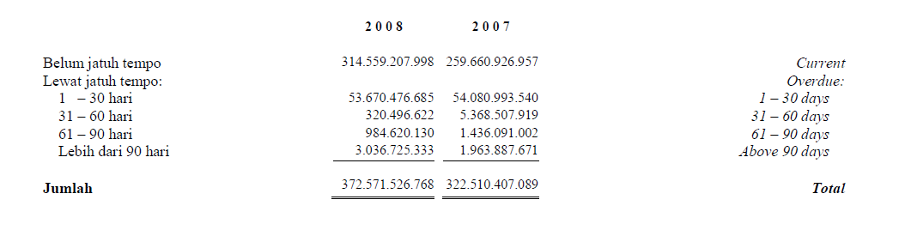
As a percentage of sales, the receivable turns out as follow:
 | 2007 | 2008 | 2009
NET SALES | 3,124,072,589,811 | 3,633,789,178,647 | 4,497,931,021,113
TOTAL AR | 344,863,621,476 | 391,158,590,681 | 482,365,826,542
Percentage | 11.0389% | 10.7645% | 10.7242%

From this analysis, we can see that even though sales increase year after year. Total Account receivable increased year after year. When converted to percentage, the answer is different to what we would expect. As Total Account receivable seems to make up less and less of the total sales as year goes by. In normal case, we would have to assume that they got better at collecting receivables, possibly getting better with their policies. However, cash on hand suggests otherwise, as we can see above the number is decreasing yearly. So the only logical assumption is bad debt write off. True, bad debt is not shown, but eliminating other possibly this seems to be the logical assumption. The AR is counted as bad debt earning, not cash. Hence, the cash on hand decrease yearly and the AR percentage decrease; even if the end result is an increased sale.
To prove this further we would have to look at the companies investing activities.
CASH FLOWS FROM INVESTING ACTIVITIES
Proceeds from Sales of Property, Plant, and Equipment | 4,253,254,044 | 5,122,629,637 | 12,062,386,600
Receipts of Cash Dividends | 3,029,942,236 | 3,720,370,165 | 11,142,448,839
Purchases of Property, Plant, and Equipment | -83,908,397,048 | -75,454,779,518 | -124,528,797,517
Proceeds from sales of Short Term Investment |  | 30,804,981,000
Net Cash used in Investing Activities | -76,625,200,768 | -35,806,798,716 | -101,323,962,078

Percent of Growth
20.44% | 135.47%
22.79% | 199.50%
-10.07% | 65.04%
 | -100.00%
-53.27% | 182.97%

As we can see, it could not be the case. The numbers show that even though the investing activities are increasing every year, the numbers are not significantly rising by an alarming rate to justify the drop in the percentage make up of account receivables as explained above. In fact, it fluctuates while if this was the cause what we should expect is it heading in one direction.
Pre Paid Expenses
This item is classified in current assets because they reflect services due that would otherwise require use of current assets.
 | 2007 | 2008 | 2009
Prepaid | 43,226,918,733 | 44,135,595,950 | 46,650,408,601

Common size
2007 | 2008 | 2009
1.56% | 1.49% | 1.43%

From the common size analysis, we can see that prepaid is decreasing in value in makeup of the total asset which is a good sign as there is fewer obligations to be meet as a whole if the worst case scenario ever happens.
Inventories
Most of the time inventories make up the largest amount of assets.
 | 2007 | 2008 | 2009
Inventories, Net | 15.52% | 18.76% | 17.93%

As a side note, pharmaceutical companies would likely use a FIFO cash flow method, taking into account the nature of the business. Expiration date is an important issue, so inventory should not be kept too long. Furthermore, with such high inflation rate (6.85% according to the central government of Indonesia.) a FIFO method would be a more logical choice.
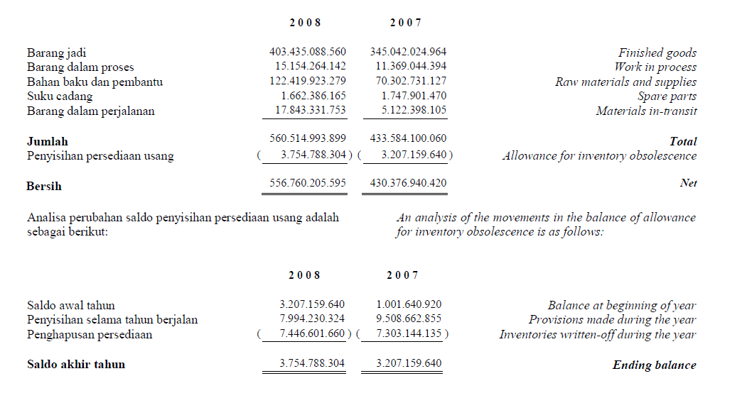
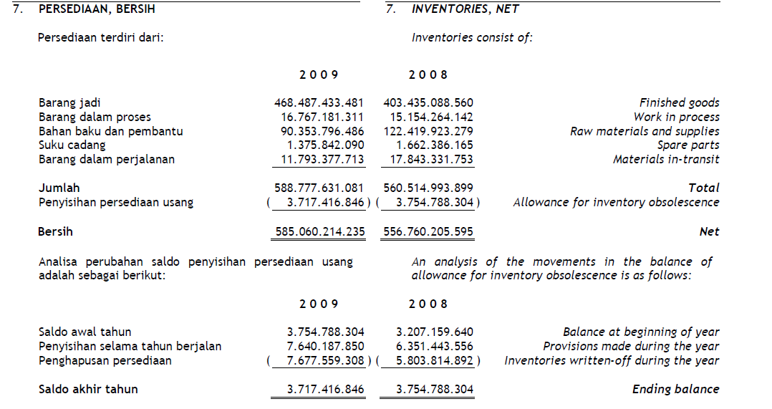
 | 2007 | 2008 | 2009
Total Inventories | 430,376,940,420 | 556,760,205,595 | 585,060,214,235

This is to show how, the company records its inventory. It should be noted that that is important to look at from this data is what happened in 2008. As the common size had showed that the amount of inventory making up the total asset had increased to the highest of the three years. This could be caused by the world financial crisis, which causes the level of sales to increase in only a smaller amount than what the company had expected.

2007-2008 | 2008-2009
Percent of Growth
16.32% | 23.78%

It might seem high when compare to the sale growth of KLBF (2007-2008 = 12.45% and 2008-2009 = 15.36) it can still not high the fact that the sales does not increase by a large amount; looking deeper if we were to see the gross profit.
2007 | 2008 | 2009
50.70% | 48.29% | 49.65%

We can see a drop in 2008, so linking it back to the data above, we can also see that 2008 provide the highest allowance for write-off. With this we can conclude that inventory suffers a setback in 2008, which the company are aware of and prepare for the worst case in these accumulations.

Long-Term Asset – Non Current Asset
Plant, Assets, and Natural Resources
The reason Property, plant, and equipment are important is because, they are noncurrent assets used in the manufacturing, merchandising, or service processes to generate revenue and cash flow for more than one period.
 | 2007 | 2008 | 2009
Property,Plant,Equipment - Net | 628,074,778,593 | 665,063,282,472 | 715,003,306,406

By the huge amount of number, we can see that the company has a high amount of asset to produce revenue.
2007 | 2008 | 2009
22.65% | 22.41% | 21.91%

However, when we look at the common size numbers, a different situation is shown. What we have here is the number of noncurrent asset decreasing year by year. Even though, it is still the highest amount in terms of total assets, it might not always be a bad sign as this could suggest that the company had utilized their total asset at a much effective rate. To confirm this we would have to look at ROA.
TSPC | TSPC
 | 2007 | 2008 | 2009
ROA | 10.04% | 10.81% | 11.03%

The ROA shows that there is increase in every year, which confirmed our points.

CASH FLOWS FROM INVESTING ACTIVITIES
Proceeds from Sales of Property, Plant, and Equipment | 4,253,254,044 | 5,122,629,637 | 12,062,386,600

If we were to look back we can see that in 2009 the company has sold on a large amount of PPE. Apart from the fact that they are utilizing the ROA to the most efficient level, this could have been done to improve them by updating equipments, or to combat against potential problems that could be caused by the financial crisis.
Depreciation
This is the allocation of the costs of the plant and equipment over their useful lives. It is one of the indirect costs incurred by the company.
The company has stated that they use the straight line method with the following information:
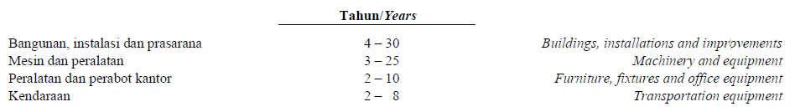
From the income statement, we can see that depreciation is as followed:
 | 2007 | 2008 | 2009
Depreciation and Amortization | 23,687,665,782 | 24,062,171,929 | 27,991,284,908

We see a huge jump in 2009, as from the investment activities the company has invested a lot in buying PPE.
 | 2007 | 2008 | 2009
Purchases of Property, Plant, and Equipment | -83,908,397,048 | -75,454,779,518 | -124,528,797,517

Furthermore, if we look at the common size, we will see that the number contributing to the sale has decrease.
2007 | 2008 | 2009
0.76% | 0.66% | 0.62%

Since, the old PPE are sold and new one are bought in; taking into account the fact that ROA has improve. This is what should be expected as the number of depreciation expense and amortization should affect less of the sales.
Intercompany activities
Transaction carried out between two units of the same corporation.
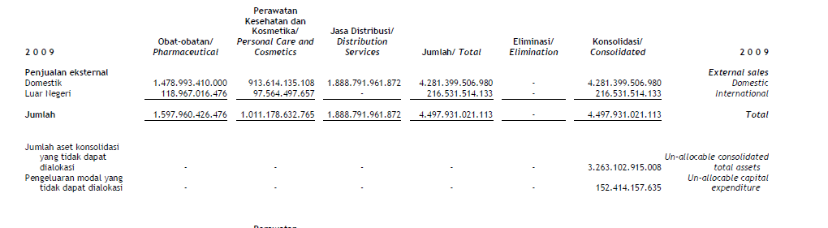
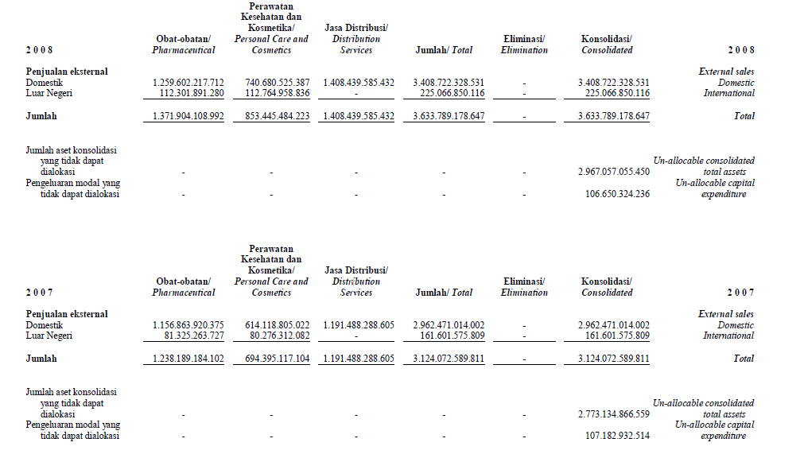

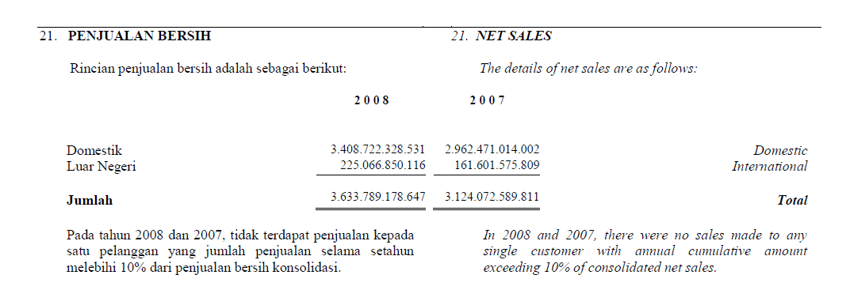

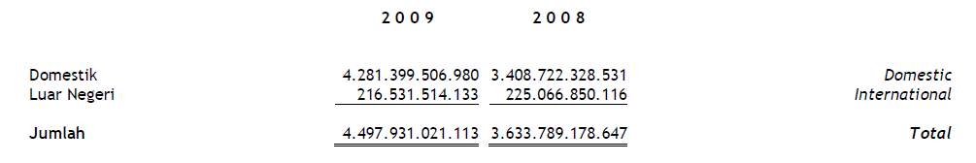
This is shown how the company consolidated the revenues of its domestic and international subsidiaries. Another aspect to look at is the company separates its subsidiaries into parts of their core businesses. These are: Pharmaceutical, Personal Care and Cosmetics, and Distribution Services.
In terms of revenue, it is increasing yearly, but if we break it down we can see it only increases for the domestic subsidiaries. The international subsidiaries revenue seems to drop in 2009; this could be because the global financing crisis affects other part of the globe more than Indonesia (the market in Indonesia remains stronger).
International Activities
Subsidiaries
From the data available, we can see the international Subsidiary of TPSC is in Thailand, Philippines, Malaysia, and Singapore. Looking back to the financial statement of 2008; In Malaysia, we have Tempo Pacific holding Ltd., which is used for Investment. In Thailand, we have International Beauty Products Ltd, which deals in cosmetics trading; we also have RT Beauty Care, which deals with Cosmetic Manufacturing. In Singapore, we have Tempo Nagadi Asia Pre, Ltd., which deals with trading business and purchasing services. In Philippines, we have Tempo Scan Pacific Philippines Inc., this subsidiary deals with Distribution and Marketing Services. They have kept the subsidiary up until today’s date.
Exchange Rate
By owning different subsidiaries in different countries, the company has to deal with foreign exchange rates. In 2008, the rates are as follow:
Currency Exchange | 2007 | 2008
US $ / Indonesia Rp | 9419 Rp | 10950 Rp
Euro / Indonesia Rp | 13750 Rp | 15432 Rp
Sin $ / Indonesia Rp | 6502 Rp | 7607 Rp
THB/ Indonesia Rp | 279 Rp | 315 Rp
PHP / Indonesia Rp | 227 Rp | 231 Rp

In 2009, the rates are as follow:
Currency Exchange | 2008 | 2009
US $ / Indonesia Rp | 10950 Rp | 9400 Rp
Euro / Indonesia Rp | 15432 Rp | 13510 Rp
Sin $ / Indonesia Rp | 7607 Rp | 6699 Rp
THB / Indonesia Rp | 315 Rp | 282 Rp
PHP / Indonesia Rp | 231 Rp | 204 Rp
The first thing to point out here would be the change in exchange rate. In 2007- 2008, we can see that the Rp had depreciated against all other currencies. This will affect the comprehensive net income, as it will be recognized as a gain on foreign currency exchange in those periods. Only one rate is used, so it should be safe to assume that the rates given are the same rate that is used on the forward contracts. In 2009, the currency has appreciated, so this time we would expect to see loss on currency exchange. Euros and dollars are used as the medium in currency exchange, while Singapore, Thailand, and Philippines are the locations of the subsidiaries.
 | 2007 | 2008 | 2009
Gain on Foreign Exchange - Net | 18,534,350,793 | 18,226,560,662 | -20,994,247,033

The next thing to do is look at the location and the activities of the subsidiaries. In Malaysia, established in 2002, since the Malaysia dollar is not mentioned in the list it can be assumed to be insignificant. The subsidiary itself is used for investment activities. So it should be fair to say that Tempo Pacific Holding bears little weight to the main business activities.
Moving on to Thailand, established in 1978 (IBP) and 1985 (RTB), Cosmetic seems to be the main activities of the subsidiaries in the country; both manufacturing and trading, and how Thai Baht is on the foreign currency exchange list. This Sub seems to bare weight to the main business activities. The company itself is old which suggest reliability and possibly quality to stay this long. Thailand is known for beauty products, and thus can produce them at the right quality for a reasonable price.
In Singapore, established in 1992, again based on the significant of the currency which suggest it has weight on the company’s main activities. What it does is trading businesses and purchasing service. The main reason Singapore is chosen could come from specialty the place could offer, similar to what Thailand has. Relationship making seems to be a key area which is required for the activity, thus, skill in communication plays an important; something that is acquired from Singapore.
The subsidiary in Philippines, established in 2007, deals with Distribution and Marketing Service, which could suggest two possibilities, one is they are also in the Philippines market, or because the Philippines provide the labor pool that is cheaper to find then inside the country so it was a better decision to off shore these activities.
ROE Analysis
Return on Common equity measures the rate of return on the ownership interest (SE) of the common stock owners. It is important as it measures a firm’s efficiency at generating profits from every unit of Shareholders equity. Companies that boast a high return on equity with little or no debt are able to grow without large capital expenditures, allowing the owners of the business to withdrawal cash and reinvest it elsewhere.

 | 2007 | 2008 | 2009
ROE | 0.1235 | 0.1423 | 0.1597

ROE shows improvement yearly; however this might not be an accurate figure as it is only the average of three years taken into accounts. A high ROE is usually in the range of 20-30%, while a company with an ROE of 5% or below should be avoid at all cost. So in this case it is still okay, even though when compare to its competitor in the same industry which shows a higher ROE like KLBF, which shows an ROE of 18% in both 2008 and 2007 and going as high as 24.6% in 2009. Factor which should be taken into consideration is they are not as big as their competitor.
DuPont Analysis
By using DuPont Analysis we can understand the change in ROE more, as it breaks down the formula into its main components. As stated above, the ROE of TPSC is still a whole and thus we could not really tell if the performance is good or not.
 | 2007 | 2008 | 20.09
Net Profit Margin | 8.91% | 8.82% | 8.00%
Total Asset Turn Over | 1.0410 | 1.2108 | 1.4988
Equity Multiplier | 1.3108 | 1.3271 | 1.3546
ROE | 12.16% | 14.18% | 16.25%

Percentage Change | 2007-2008 | 2008 - 2009
Net Profit Margin | -0.0097 | -0.0931
Total Asset Turnover | 0.1632 | 0.2378
Equity Multiplier | 0.0125 | 0.0207
ROE | 0.1663 | 0.1459

Net Profit Margin
In term of net profit margin, this is a point worth looking as it is unlikely company would lower their margin. Margin act as a safety cushion, the margin the more room there is for errors. So a high margin is always preferable. However in a bid to attract higher sales, the management could go for lower margin. This low-cost, high-volume approach has turned companies such as Wal-Mart and Nebraska Furniture Mart into absolute giants.
Compare to its competitor like KLBF, which has Net profit margin of 10% in 2007; 8.97% in 2008; and 10.22% in 2009. We can see that KLBF holds a better margin than TPSC, the drop in 2008 could be reflected from the global financial crisis, what is important to point out here is TPSC does not seem to be able to recover from the crisis (in terms of the margin), while KLBF had. Another possible explanation is TPSC pursuit a more aggressive strategy in order to boost sales.
Total Asset Turnover
This component measure of how effectively a company converts its assets into sales. The asset turnover ratio acts as a counter to the net profit margin; i.e., the higher the net profit margin, the lower the asset turnover. The result is that the investor can compare companies using different models (low-profit, high-volume vs. high-profit, low-volume) and determine which one is better to invest in.
From the table we can see that TPSC holds a high Asset turnover, this is understandable as they are in a sales business, so high volume is of important concern. Combine with the margin analysis above, it could be shown they are being more aggressive with the strategy, while the competitor KLBF seems to want to keep hold of a larger safety cushion. Total Asset Turnover of KLBF is 1.23 in 2007; 1.364 in 2008; and 1.574 in 2009. As we can see they also have a high total asset turnover which means it is the industry.

Equity Multiplier (Financial Leverage)
It is possible for a company with terrible sales and margins to take on excessive debt and artificially increase its return on equity. The equity multiplier, a measure of financial leverage, allows the investor to see what portion of the return on equity is the result of debt.
So what this means is in order to actually see the big picture of the ROE, the number we should really focus is how would the ROE of the company be if it is completely debt free, in other words remove Equity Multiplier from the ROE.
 | 2007 | 2008 | 2009
ROE | 9.2752% | 10.6844% | 11.9944%

This is not bad as the ROE has not decreased by a significant amount, and it had not dropped below the level of 5%. However, when compare to its competitor KLBF. In 2007 the ROE is 12.22%; in 2008 it is 12.24%; and in 2009 it is 16.09%. So it while it is not bad, it is still not that really good when compare to competitor in the same industry. There is still more room for improvement though as the number differences are not that quite different.
To conclude the ROE analysis using DuPont analysis, we can say that even though KLBF has higher ROE than TPSC, the industry ROE is not as high as we thought in the beginning but rather in the average. Both companies have a good management team. But, the size of KLBF has allowed it to have competitive advantage in the industry, and that it would be sometime if TPSC were to overtake KLBF position.

Financial Statement Analisys
Tempo Scan Pacific
With Comparisons to Kalbe Farma



CREDIT ANALISYS
Liquidity
Liquidity refers to the availability of company resources to meet short-term cash requirements. It is the ability to convert assets into cash or to obtain cash to meet short-term obligations.
Short term in this case is a period up to one year, though it is identified with the normal operating cycle of the company (buying-selling-collecting cycle).
A company short-term liquidity risk is affected by the timing of cash inflows and outflows along with its prospects for future performance.

Liquidity Analysis
This analysis is aimed at companies’ operating activities, their ability to generate profits from sale of products and services, and working capital requirements and measures.

Why is liquidity analysis important?
The reason behind this is because being unable to meet short-term obligations resulted in negative repercussions. The company will not be able to take advantage such as favorable discounts or profitable opportunities. Moreover, this can lead to other problems which includes, forced sale of investments and other assets at reduced prices. The worst case that could happen would be insolvency and bankruptcy.
For the shareholders, if their company lacks the ability to meet the obligations then that can be used to foretell a loss of owner control or loss of capital or loss of capital investment. It is worst in situation where the owner is faced with unlimited liability (proprietorships and certain partnerships), because their personal assets will be used to cover the excess amounts.
Creditors are worried as the lack of liquidity can yield a delay in collecting interest and principal payments or the loss of amounts due them.
Customers and suppliers are also affected by this problem. As it could result in the company’s inability to execute contracts and ultimately damage to important customer and suppliers relationships.
To sum up, it shows whether the company can keep on existing or not.

Part I – Working Capital Analysis

Liquidity and Working capital
Working capital is widely used to measure liquidity. As we all know working capital is the excess of current assets over current liabilities. It acts as the measure of liquid assets that provide a safety cushion to creditors. It can tell what is left in the liquid reserve to meet contingencies and the uncertainties surrounding a company’s balance of cash inflows and outflows.

Current Asset and Current Liabilities
Current assets are cash and other assets reasonably expected to be realized in cash or sold or consumed within one year (or nominal operating cycle). These includes: cash, marketable securities, accounts receivable, inventories, and prepaid expenses.
Current liabilities are obligations expected to be satisfied within a short period of time, usually one year. These includes: accounts payable, note payable, short-term bank loans, taxes payable, accrued expenses, and the current portions of long term debt.
As some company might try to make their balance sheet look nice, we must assess whether all the current obligations are reported. Three common concerns are:
- Contingent liabilities associated with loan guarantees
- Future minimum rental payments under noncancelable operating lease agreements
- Contracts for construction or acquisition of long term assets, as they often call for substantial progress payment.

Applying NWC
Let’s compare the net working capital of both TPSC and KLBF, within the three years period.
As the data is shown, KLBF has a larger amount of net working capital than TPSC. But for a clearer picture we should also look at the current asset and current liabilities of both companies.

 |  | TSPC
 |  | 2007 | 2008 | 2009
NWC |  | 1,404,234,754,591 | 1,518,650,122,632 | 1,675,348,626,415

 | KLBF
 | 2007 | 2008 | 2009
NWC | 3,005,377,512,270 | 2,917,683,005,573 | 3,127,755,102,214

TSPC - Current Asset
 | 2007 | 2008 | 2009
Cash & Cash Equivalents | 951,992,371,407 | 1,008,252,575,497 | 1,180,730,614,170
Short-Term Investments - Net | 93,471,187,347 | 54,847,862,157 | 59,269,550,777
Trade Receivables
# Third Parties | 319,680,812,021 | 371,395,711,788 | 464,056,240,077
# Related Parties | 2,829,595,068 | 1,175,814,980 | 571,474,113
Other Receivables
# Third Parties | 10,037,824,009 | 17,324,261,077 | 17,105,853,926
# Related Parties | 12,315,390,378 | 1,262,802,836 | 632,258,426
Inventories, Net | 430,376,940,420 | 556,760,205,595 | 585,060,214,235
Prepaid | 43,226,918,733 | 44,135,595,950 | 46,650,408,601
Current Assets | 1,863,931,039,383 | 2,055,154,829,880 | 2,354,076,614,325

TSPC - Current Liabilities
Bank Loans | 22,619,000,000 | 32,700,000,000 | 63,600,000,000
Trade Payable
# Third Parties | 268,816,435,393 | 352,759,143,923 | 439,569,819,437
# Related Parties | 24,620,170,553 | 1,116,271,324 | 5,492,939,585
Other Payable
# Third Parties | 55,420,425,250 | 62,745,815,133 | 59,371,652,764
# Related Parties | 8,445,412,938 | 7,927,421,414 | 5,486,996,989
Accrued Expense | 38,577,086,922 | 55,971,167,596 | 82,468,200,813
Taxes Payable | 40,330,998,817 | 22,325,316,110 | 21,032,922,319
Current Maturities of Obligations under Capital Lease | 866,754,919 | 959,571,748 | 1,705,456,003
Current Liabilities | 459,696,284,792 | 536,504,707,248 | 678,727,987,910

KLBF - Current Asset
 | 2007 | 2008 | 2009
Cash & Cash Equivalents | 1,116,346,134,197 | 1,321,797,625,299 | 1,562,664,177,408
Short-Term Investments - Net | 175,833,152,370 | 124,748,588,599 | 62,596,260,106
Trade Receivables | 869,572,349,473 | 935,357,382,409 | 1,203,940,830,063
Other Receivables | 57,501,290,031 | 65,803,613,758 | 114,138,739,079
Inventories, Net | 1,427,067,984,707 | 1,606,123,881,887 | 1,561,382,418,796
Other Current Assets | 113,686,715,546 | 114,223,744,576 | 197,170,092,624
Current Assets | 3,760,007,626,324 | 4,168,054,836,528 | 4,701,892,518,076

KLBF -Current Liabilities
Short-Term Loans | 43,716,669,680 | 145,888,622,451 | 339,131,952,804
Trade Payable | 328,290,780,126 | 305,567,569,948 | 481,511,454,167
Other Payable | 45,740,153,224 | 92,524,190,230 | 119,835,349,852
Accrued Expense | 207,403,837,295 | 269,366,487,438 | 359,976,797,639
Taxes Payable | 127,041,938,910 | 177,900,635,770 | 273,181,447,326
Current Maturities of Long-Term Debt
# Obligations under Finance Leases |  | 574,290,696 | 500,414,074
# Bonds Payable - Net | 2,436,734,819 | 258,550,034,422
Current Liabilities | 754,630,114,054 | 1,250,371,830,955 | 1,574,137,415,862

By Comparison, KLBF leads TPSC in both current assets and current liabilities by twice the amount. On a quick glance, with twice the amount and a net working capital of more than twice the amount; it can be assumed that KLBF holds a more superior position in terms of net working capital.

Current ratio measure of liquidity
But as I mentioned, the above method was only viewed at a quick glance, it cannot tell the whole story behind the number, and let alone the fact of really how both company are doing with their working capitals. So what does current ratio measures?
- Current liability coverage. Can we be assured that current liabilities will be paid?
- Buffer against losses. How wide is the margin of safety?
- Reserve of liquid funds. Is the margin of safety withstand able against uncertainties and random shocks to a company’s cash flows?

Limitation to be aware
Current ratio does not:
- Measure and predict the pattern of future cash inflows and outflows
- Measure the adequacy of future cash inflows to outflows
The current ratio is a static measure of resources available at a point in time to meet current obligations. You cannot suddenly use it to base on future cash inflow as there will not be a causal relationship between the two.

Furthermore, as we may be aware of in facts about liquidity current ratio, such as:
- Liquidity depends to a large extent on prospective cash inflows and to a lesser extent on level of cash and cash equivalents.
- No direct relation exists between balances of working capital accounts and likely patterns of future cash flows.
- Managerial policies regarding receivables and inventories are directed primarily at efficient and profitable asset utilization and secondarily at liquidity.
With these set of information, you might argue that we should not use current ratio at all because it looks as if it cannot really answer to whole questions. However, we cannot dismiss it immediately and the reason it is a widespread tool is because:
- Understandability
- Simplicity in computation
- Data availability
- View from a creditor point of view that if cash flow suddenly stops what would happen (the last resort)
The use of current ratio is only used to measure the ability of current asset to discharge current liabilities.

Comparative Analysis
We can use current ratio to see its change overtime. But we must look into further detail, as a negative or positive change in the current ratio does not really mean there is change in the company’s liquidity or operating performances. For example: during a recession a company might continue to pay current liabilities while inventory and receivables accumulate, ending in an increase in the current ratio; or in a successful period, increases in current liabilities (tax payable) could lead to a lower current ratio; or an expansion can create a larger need for working capital, which ultimately decrease current ratio and thus a “prosperity squeeze” as the net working capital will not increase against the ratio.
So let’s look at the current ratio of both companies, which again will be based on three years analysis.
TPSC
 | TSPC
 | 2007 | 2008 | 2009
Current Asset | 1,863,931,039,383.00 | 2,055,154,829,880.00 | 2,354,076,614,325.00
Current Liabilities | 459,696,284,792.00 | 536,504,707,248.00 | 678,727,987,910.00
NWC | 1,404,234,754,591 | 1,518,650,122,632 | 1,675,348,626,415
Current Ratio | 4.054701117 | 3.830637089 | 3.468365319

As we can see TPSC current ratio is dropping. We must look further into this to really see if this is by the companies own performance or not. What I can analyze now it, firstly the change in percentages. For current asset, from 2007 to 2008 it had increased by 10.26%; and from 2008 to 2009 it had increased by 14.55%. For current liabilities it is 16.71% and 26.5% respectively.
This shows that although current assets increase, current liabilities has further increased in a larger amount. By looking into the balance sheet above, on glance, the increase in outstanding bank loan can be spotted right away. Then we have a drop in investment in 2008. By assumption it can be an outside factor (world’s financial crisis) that affected the company and cause it to struggle. I don’t want to judge the company’s performance right away because as shown above the net working capital is increasing and I have not analyzed the operating activities. So at this point I would have to see if KLBF is affected by the same situation or not.

KLBF
 | KLBF
 | 2007 | 2008 | 2009
Current Asset | 3,760,007,626,324.00 | 4,168,054,836,528.00 | 4,701,892,518,076.00
Current Liabilities | 754,630,114,054.00 | 1,250,371,830,955.00 | 1,574,137,415,862.00
NWC | 3,005,377,512,270 | 2,917,683,005,573 | 3,127,755,102,214
Current Ratio | 4.982583595 | 3.333452285 | 2.986964461

I would like to start off by looking at the increase of both Current Assets and Current Liabilities. For the Current assets change from 2007 to 2008 it is 10.85% and from 2008 to 2009 it is 12.81%. The Current liabilities changes are 65.69% and 25.89%. On glance, we can see in 2008 the net working capital faced a drop, and then current liabilities goes up to a staggering 65.69%; while things seem to be back to normal in 2009. By looking back in the balance sheet on the liabilities part, we can see that short term loan has taken a sudden increase. I deduce that it could possibly be because of their recent investment in Singapore.
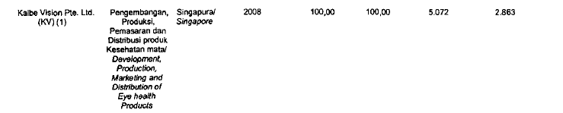
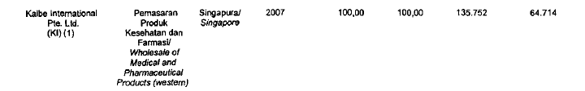
Kalbe Vision, is newly in operation with the purpose of develop eye health products. What can be seen is they will have a skilled labor force to manage the business (Singaporean labor pool) and a lower tax. Kaibe international, will deal with distributing to the western market. This is also further back by the fact that that the net working capital took a drop in 2008.
The cash outflow for investing activities data should also be pulled up for analysis.
 | 2007 | 2008 | 2009
CASH FLOWS FROM INVESTING ACTIVITIES
Proceeds from Sales of Short Term Investment | 883,224,708,073 | 187,963,817,622 | 149,516,929,663
Interest Incomes Received | 70,719,155,436 | 56,492,357,164 | 66,981,541,962
Proceeds from Sales of Property, Plant, and Equipment | 24,829,307,166 | 10,172,535,153 | 20,331,541,962
Advance for Sale of Log-Term Investment Received |  |  | 1,263,900,400
Acquisitions of Subsidiaries Shares from Third Parties |  |  | -522,124,829,650
Acquisitions of Property, Plant, and Equipment | -224,597,075,433 | -305,198,137,295 | -277,596,519,508
Placements in Short-Term Investments and Time Deposits | -796,516,017,307 | -135,870,696,543 | -84,443,721,852
Proceeds from Other Investing Activities | 68,838,853 | 215,179,709 | 631,147,163
Net Cash used in Investing Activities | -42,271,083,212 | -186,224,944,190 | -645,440,009,860
From the data above, we can see that investing activities does increase, and the net cash outflow increased about 340.55% as a change from 2007 to 2008. The current ratio of the company has also dropped, but as I have mentioned, this does not immediately translate to a poor performance since I have not analyze the operating activities.
The Rule of Thumb
As you might have noticed, I have not said that the company is in danger of not being able to follow its short term obligations even though they are both faced with constant dropping of the current ratio. This is because the rule of thumb stated that if the current ratio is 2:1 or better then a company is financially sound. This basically implied that for every $1 of current liabilities, there is $2 of current assets to cover it. So even if the value shrinks by half, its short term obligation is still covered. But do not be completely relax as everything cannot be overlooked, a ratio of 2:1 or better could also imply that they are not using their resources efficiently and this could be backed if the return on asset is not as high.
So with this information, let’s look at the ROA for both companies.
TSPC | TSPC
 | 2007 | 2008 | 2009
ROA | 10.04% | 10.81% | 11.03%

KLBF | KLBF
 | 2007 | 2008 | 2009
ROA | 13.73% | 12.39% | 14.33%
On glance, you might directly spot two facts. First is, even though TPSC has a better current ratio in 2009, KLBF leads in term of return on assets by three percentage point. This could mean KLBF utilized their net asset towards net income better than TPSC. Second fact you might notice is, in 2008 KLBF ROA dropped. By looking back at the income statement, net income growth in 2008 for KLBF is only .16%; this small growth could be the reason why ROA dropped. Since their asset did increase, so what should have been expected is a follow increase in ROA. I speculate that, the company increases its investing activities. As evident by an increase in cash outflow towards the investing activities in 2008 (340.55%), plus the financial crisis that seem to affect both companies could be the reason. We of course do see a sales growth of 12.45%, so the main reason cannot be because sales dropped.

Net trade Cycle Analysis
A company’s working capital requirements are affected by its desired inventory investment and the relation between credit terms from suppliers and those extended to customers. Thus, by looking at company’s net trade cycle, we will have an understanding of how big it required working capital will be.
Keeping in mind, the longer the net trade cycle, the larger is the working capital requirement. So by comparing the industry current ratios, and analysis of working capital requirements using net trade cycle measures, are useful in analysis of the adequacy of a company’s working capital.
So let’s look at the net trade cycle of both TPSC and KLBF.
TSPC - 2009
A/R | 38.61 | days
Inventories | 74.63 | days
 | 113.23 | days
Less: A/P | 65.22 | days
Net Trade Cycle (days) | 48.02 | days
TPSC - 2008
A/R | 38.75 | days
Inventories | 90.32 | days
 | 129.07 | days
Less: A/P | 65.27 | days
Net Trade Cycle (days) | 63.79 | days
KLBF - 2009
A/R | 52.22 | days
Inventories | 122.85 | days
 | 175.07 | days
Less: A/P | 41.90 | days
Net Trade Cycle (days) | 133.16 | days

KLBF - 2008
A/R | 45.75 | days
Inventories | 141.94 | days
 | 187.69 | days
Less: A/P | 28.51 | days
Net Trade Cycle (days) | 159.18 | days

As we can see from the data, KLBF has a longer Net Trade Cycle then TPSC. This correlates with the fact of KLBF having a larger NWC than TPSC. Both companies seem to improve on inventories turnover, as the number had decreased significantly. This could however, be effected by the financial crisis, which could cause inventory to be accumulated from previous. The reason I point out only inventory is because if we look at the change in other areas of TPSC we can see that the change is only minor; as deduced this alone tells us that the company or its supplier is not doing poorly. However, things seem to be different with KLBF. Where both A/P and A/R has increased by an amount; up until this point the evidence seems to be pointing that TPSC is a more stable company then KLBF in terms of meeting short term obligations.

Cash-based ratio measures of liquidity
Cash and cash equivalent are the most liquid of current assets. There are two ratios which is used to measure this item.

Cash to Current Assets Ratio
This ratio is used to measure the degree of current asset liquidity. The larger this ratio is the more liquid are the current assets.
TPSC
 | 2007 | 2008 | 2009
Cash to Current Asset Ratio | 0.56 | 0.52 | 0.53

KLBF
 | 2007 | 2008 | 2009
Cash to Current Asset Ratio | 0.34 | 0.35 | 0.35
as we can see right away that TPSC current asset is more liquid then KLBF.

Cash to Current Liabilities Ratio
This ratio measures the cash available to pay the obligation. Some people might argue that this is an extreme decision because it just takes into account how much cash on hand can the company use to subsidize its short-term obligation, while some might see it as an extension of quick ratio. But ultimately, nothing in the balance sheet should be deemed unimportant. Cash is still an important instrument as we should not forget; many companies (insolvent ones) do fail because they are tied up in noncash assets and no ability to cover its liabilities.
In this case, provided in the example below the larger the ratio, the better it is.
TPSC
 | 2007 | 2008 | 2009
Cash to Current Liabilities Ratio | 2.27 | 1.98 | 1.83

KLBF
 | 2007 | 2008 | 2009
Cash to Current Liabilities Ratio | 1.71 | 1.16 | 1.03

Following up from the Cash to Current Assets ratio above, we can see that TPSC ability to cover short-term obligations with cash assets alone is far better than that of KLBF.

Part II - Operating Activity Analysis of Liquidity

There are three operating measures which is important in credit analysis.
They are:
- Accounts Receivables
- Inventory
- Current liabilities

Accounts Receivable liquidity measures
For most companies selling on credit, accounts and note receivable are an important part of working capital. As liquidity is about the matter of can the company meet short term obligation; it would be essential to know if these cash (on credit) can really be obtained in the full amount (no bad debt). In other words, can the collection be done without loss? As it is arguable that the longer the collection period, the less chance it is that all the amount would be received. Thus, the turnover rate can be used to indicate the age of these receivable.

Accounts Receivables Turnover
TPSC
 | 2007 | 2008 | 2009
Net Sales | 3,124,072,589,811 | 3,633,789,178,647 | 4,497,931,021,113
Average A/R | 406,129,346,233.00
A/R Turnover | 7.692309405 | 8.947369138 | 11.07511945

KLBF
 | 2007 | 2008 | 2009
Net Sales | 7,004,909,851,908 | 7,877,366,385,633 | 9,087,347,669,804
Average A/R | 1,082,104,734,937.67
A/R Turnover | 6.47341207 | 7.279670933 | 8.397844845
The receivables turnover ratio indicates how often, on average, receivable resolve (receive and collected during the year; in other words, the more the better. As we can see from above, the A/R turnover ratio for TPSC is always higher than KLBF, which suggested that they seem to be better at collecting the receivable.

Days’ Sales in Receivables
Account Receivables turnover ratio measures the speed of collections and is useful for comparison. It cannot tell us a direct comparison to the term of trade a company extends to its customers.
This is when Days’ Sales in receivable comes into play, it is done by converting accounts receivable turnover ratio into number of days

TPSC
 | 2007 | 2008 | 2009
Days' Sales in Receivables | 46.79999 | 40.23529 | 32.50529

KLBF
 | 2007 | 2008 | 2009
Days' Sales in Receivables | 55.61209 | 49.452785 | 42.86814

The trend in collection period over time helps asses the quality and liquidity of receivables. It should also be noted that the account receivables written in the balance sheet has already been subtracted with allowance for bad debt. As we can see for TPSC, their days’ sales in receivable are better than that of KLBF. We can assume from the data that both companies seem to be better at their collecting policies. However, if that’s the case then they should not try to push their customers too much, as that could result in a negative affect towards relationship. It could also be interpreted that the industry of their customers could be at a rise (good business), as both of the companies see an improvement in the collection period; as such, customers pay on time and does not suffer from financial distress. This could be drawn to the fact that Indonesia is in an inflation period, 6.85% according to the central government of Indonesia.

Inventory Turnover Measures
Most of the time inventories make up the largest amount of assets. It seems to be no different in this industry, as evidence by what both companies hold. We should look at the common-size for both companies.

TPSC
 | 2007 |  | 2008 |  | 2009
Cash & Cash Equivalents | 34.33% |  | 33.98% |  | 36.18%
Short-Term Investments - Net | 3.37% |  | 1.85% |  | 1.82%
Trade Receivables
# Third Parties | 11.53% |  | 12.52% |  | 14.22%
# Related Parties | 0.10% |  | 0.04% |  | 0.02%
Other Receivables
# Third Parties | 0.36% |  | 0.58% |  | 0.52%
# Related Parties | 0.44% |  | 0.04% |  | 0.02%
Inventories, Net | 15.52% |  | 18.76% |  | 17.93%
Prepaid | 1.56% |  | 1.49% |  | 1.43%
Current Assets | 67.21% | 69.27% |  | 72.14%

KLBF
 | 2007 | 2008 | 2009
Cash & Cash Equivalents | 21.73% | 23.17% | 24.11%
Short-Term Investments - Net | 3.42% | 2.19% | 0.97%
Trade Receivables | 16.92% | 16.40% | 18.57%
Other Receivables | 1.12% | 1.15% | 1.76%
Inventories, Net | 27.77% | 28.16% | 24.09%
Other Current Assets | 2.21% | 2.00% | 3.04%
Current Assets | 73.18% | 73.07% | 72.53%

Even though, TPSC seems to have low level of inventory making up the current assets, it should also be noted that this could be a positive sign as it could mean they are utilizing inventory at a more effective level then KLBF.
We should not forget that keeping high inventory does not really help with sudden liquidation, as inventories are quite hard to liquidate at a short period. It however is used for purpose of obtaining a return through sale to customers. In one case, if inventory is too low, then a company could face with cost of loss sales. However, if they keep it too high it could lead to extra costs towards itself (Insurance, storage, taxes, and product expiry date); moreover, it can also tied up funds which could be used elsewhere. As such, this is why it is the least liquid able current assets and a good reason of why how a company deals with inventory should be used to analyze liquidity.

Inventory Turnover
An inventory turnover ratio is used to measures the average rate of speed in which inventories move through and out of a company, similar to what we did with accounts receivable.
TPSC
 | 2007 | 2008 | 2009
CoGs | 1,844,478,324,134 | 2,219,244,777,770 | 2,822,351,586,347
Average Inventory | 524,065,786,750
Inventory Turnover | 3.519554931 | 4.234668307 | 5.385491016

KLBF
 | 2007 | 2008 | 2009
CoGs | 3,453,279,199,660 | 4,073,725,872,514 | 4,575,407,367,444
Average Inventory | 1,531,524,761,797
Inventory Turnover | 2.25479815 | 2.659915121 | 2.987485075

From what we can see above, TPSC is doing way better in terms of inventory turnover. As a side note, pharmaceutical companies would likely use a FIFO cash flow method, taking into account the nature of the business. Expiration date is an important issue, so inventory should not be kept too long. Furthermore, as mentioned above, with such high inflation rate (6.85%) a FIFO method would be a more logical choice. I have also look up the data, which according to Bloomberg, the average turnover of pharmaceutical companies in the US is 2.02. So TPSC is doing way better in that term, making its future prospect a lot brighter.

Days’ Sales in Inventory
Another measure of inventory turnover useful in assessing a company’s purchasing and production policy is the Days’ Sales in Inventory. This ratio will tell us the number of days required to sell ending inventory assuming a given rate of sales.
So let’s take a look that this ratio for both companies.
TPSC
 | 2007 | 2008 | 2009
Days' Sale in Inventory | 102.2857 | 85.012562 | 66.84627

KLBF
 | 2007 | 2008 | 2009
Days' Sale in Inventory | 159.6595 | 135.34266 | 120.5027
As we can see the Days’ Sales in Inventory does correlated with the inventory turnover ratio. As such, we can conclude that both companies have an effective inventory management.

Conversion Period
Another useful inventory liquidity measure is its conversion period or the operating cycle. This is done by combining the information we now have, which is Days’ Sales in Receivables and Days’ Sales in Inventories. This is used to measure the time interval to convert inventories to cash.
TPSC
 | 2007 | 2008 | 2009
Conversion Period | 149.0856 | 125.2479 | 99.35157

KLBF
 | 2007 | 2008 | 2009
Conversion Period | 215.2716 | 184.7954 | 163.3708

This implies that it takes TPSC 149 days in 2007; 125 days in 2008; and 99 days in 2009 to both sell its inventory and to collect the receivables, based on current levels of receivables and inventories. As such, from what we got so far, we can say that TPSC seems to be more efficient in terms of this collection period.
A note to watch out here is if the company uses a LIFO cash flow method, it would not be accurate to compare as inventory would not be note at the same period of time (different year and different price). But as explained above this is not a problem in the case.

Liquidity of Current Liabilities
The reason we need to assess the current liabilities is because:
- It can be used to determine the margin of safety
- Used to know the working capital
Up until this point, we have been talking about current liabilities from a liquidation point of view. In truth, it is more about refunding and not paid off as the main concern. In normal cases, current liabilities tend to increase with increasing sales.
Current liabilities should be judged on their degree of urgency in payment. As we may be aware of, there are several obligations that must be met at each period of time. For example, tax payable for the federal and accounts payable towards suppliers. When revenue is produced, what expenses gets paid off first?
In this case, accounts payable turnover can be used to measure how good the company is at meeting obligation towards their suppliers.

Accounts Payable Turnover
TPSC
 | 2007 | 2008 | 2009
CoGs | 1,844,478,324,134 | 2,219,244,777,770 | 2,822,351,586,347
Average A/P | 364,124,926,738
Inventory Turnover | 5 | 6 | 8

KLBF
 | 2007 | 2008 | 2009
CoGs | 3,453,279,199,660 | 4,073,725,872,514 | 4,575,407,367,444
Average A/P | 371,789,934,747
Inventory Turnover | 9 | 11 | 12

The above ratio indicates the speed at which a company pays for purchases on account. Base on this data, we can see that KLBF is ahead of TPSC. These figures are good for maintaining supplier relationships, or it could be because their suppliers have applied a more strict policy.

Days’ Purchases in Accounts Payable
This measure is used to know the extent in which companies “lean on the trade”, or how many days outstanding are they.
TPSC
 | 2007 | 2008 | 2009
Average Payable Days Outstanding | 71.06886 | 59.06738 | 46.4453

KLBF
 | 2007 | 2008 | 2009
Average Payable Days Outstanding | 38.75863 | 32.855519 | 29.253

This ratio provides an indication of the average time the company takes in paying its obligations to suppliers. The longer the payment period, the greater the use of suppliers’ capital.
Again, it does correlated with the fact that KLBF is more efficient at obliging to paying back their suppliers. A larger Account Payable turnover and lower days outstanding. However, an interesting point here is that TPSC does not remain constant but is getting better every year at meeting the obligations towards suppliers.

Part III - Additional Liquidity Measures
There are other methods which could be used to measure the liquidity of a company.
These are:
- Current Assets Composition
- Acid-Test (Quick) Ratio
- Cash Flow Measures
- Financial Flexibility
- Management’s Discussion and Analysis
- What-if Analysis

Current Asset Composition
We can basically use common-size analysis to determine the liquidity of a company. It grants us to see how much each item in our current assets makes up the total liabilities.

TPSC
 | 2007 |  | 2008 |  | 2009
Cash & Cash Equivalents | 34.33% |  | 33.98% |  | 36.18%
Short-Term Investments - Net | 3.37% |  | 1.85% |  | 1.82%
Trade Receivables
# Third Parties | 11.53% |  | 12.52% |  | 14.22%
# Related Parties | 0.10% |  | 0.04% |  | 0.02%
Other Receivables
# Third Parties | 0.36% |  | 0.58% |  | 0.52%
# Related Parties | 0.44% |  | 0.04% |  | 0.02%
Inventories, Net | 15.52% |  | 18.76% |  | 17.93%
Prepaid | 1.56% |  | 1.49% |  | 1.43%
Current Assets | 67.21% | 69.27% |  | 72.14%

KLBF
 | 2007 | 2008 | 2009
Cash & Cash Equivalents | 21.73% | 23.17% | 24.11%
Short-Term Investments - Net | 3.42% | 2.19% | 0.97%
Trade Receivables | 16.92% | 16.40% | 18.57%
Other Receivables | 1.12% | 1.15% | 1.76%
Inventories, Net | 27.77% | 28.16% | 24.09%
Other Current Assets | 2.21% | 2.00% | 3.04%
Current Assets | 73.18% | 73.07% | 72.53%

When compare, we can see the numbers are quite similar with cash, account receivable, and inventories as the leading items. In terms of cash and A/R it seems both companies are doing well. However, it should be point out that both of the two companies inventory did go up in 2008; which can bring up the old point of the financial crisis, causing inventory to accumulate and sales to increase in by a little.

Acid-Test (Quick) Ratio
As mentioned above, inventory is considered the least liquid item in the current assets. So by removing it away, we can really see if the firm to have the ability to meet short term obligations. But we should not forget that, this might not always be the case and inventory for some companies is more liquid than slow-paying accounts receivable.
TPSC
 | TSPC
 | 2007 | 2008 | 2009
Current Asset | 1,863,931,039,383.00 | 2,055,154,829,880.00 | 2,354,076,614,325.00
Current Liabilities | 459,696,284,792.00 | 536,504,707,248.00 | 678,727,987,910.00
CA-INV | 1,433,554,098,963 | 1,498,394,624,285 | 1,769,016,400,090
Quick Ratio | 3.12 | 2.79 | 2.61

KLBF
 | KLBF
 | 2007 | 2008 | 2009
Current Asset | 3,760,007,626,324.00 | 4,168,054,836,528.00 | 4,701,892,518,076.00
Current Liabilities | 754,630,114,054.00 | 1,250,371,830,955.00 | 1,574,137,415,862.00
CA-INV | 2,332,939,641,617 | 2,561,930,954,641 | 3,140,510,099,280
Quick Ratio | 3.09 | 2.05 | 2.00

The interpretation is similar to that of the current asset where a ratio of 2 or better would mean the company is still financially sounded. For TPSC it is still considered safe, it could come from the fact that they are getting better with operating activities that is why the current ratio is dropping. Not because they are doing worst, but because they are utilizing their asset more efficiently. In KLBF case, they can still cover their obligation but they are already at 2, so this year’s balance sheet should be an indicator of saying will this ratio continue to go down that direction?

Cash Flow Measures
What we have talked about so far is how static the current liquidity measurement methods are. In the real world, apart from an extreme case, cash flows would not stop suddenly. Moreover, with a stop cash flow it would then mean you would have to cover with whatever you have left (current assets). Thus Cash flow measures are used as a dynamic approach, since it reflects the flows variable.
TPSC
 | TSPC
 | 2007 | 2008 | 2009
Current Asset | 1,863,931,039,383.00 | 2,055,154,829,880.00 | 2,354,076,614,325.00
Current Liabilities | 459,696,284,792.00 | 536,504,707,248.00 | 678,727,987,910.00
Operating Cash Flow | 294,712,577,526.00 | 292,296,080,215.00 | 476,589,761,145.00
Cash Flow Ratio | 0.64 | 0.54 | 0.70
KLBF
 | KLBF
 | 2007 | 2008 | 2009
Current Asset | 3,760,007,626,324.00 | 4,168,054,836,528.00 | 4,701,892,518,076.00
Current Liabilities | 754,630,114,054.00 | 1,250,371,830,955.00 | 1,574,137,415,862.00
Operating Cash Flow | 362,898,238,846.00 | 807,700,535,344.00 | 1,363,583,440,601.00
Cash Flow Ratio | 0.48 | 0.65 | 0.87
As we can see, in 2007 Cash flow ratio for TPSC is quite high. In fact, it is higher than KLBF. However, in 2008 the Cash flow ratio dropped. By looking at the statement of Cash flow, we can see that cash for operation has decreased. From 437,537,652,740 (2007) to 418,868,762,082 (2008) as payment to customers and suppliers have increased 2,691,150,952,301 (2007) to 3,230,341,841,878 (2008). Again this sudden increase could likely be caused by the financial crisis, which addresses the need for the company to decrease spending in preparation for worst case scenarios. By looking at KLBF for the exact same point, we can see that cash for operations have only increased by a small amount from 2,538,548,622,667 (2007) to 2,768,561,544,591 (2008). As of 2009, both company cash flow ratios seem to be well, with KLBF having a higher ratio of 17 points more than TPSC. This shows that its cash flow can meet obligations better.

Financial Flexibility
This is the ability of a company to take steps to counter unexpected interruptions of flow of fund. It includes the ability to:
- Borrow from various sources
- Raise equity capital
- Redeploy assets
- Adjust level and direction of operations to meet changing circumstances

Factors that influence these are:
- Profitability
- Stability
- Size
- Industry Position
- Asset Composition
- Capital Structure

Additional factors:
- Ratings of its commercial paper, bonds, and preferred stocks
- Restriction on sales of assets
- The extent of expense discretion
- Ability to respond quickly to change environment conditions (strikes, demand shifts, and breaks in supply resources)

SOLVENCY ANALISYS

Solvency analysis mostly deals with company ability to cover it’s long term liabilities, before we delve into the solvency analysis, lets understand that long term liabilities occurred for reasons, and those reasons related to the long term features of the liabilities. In other word we can expect that long term liabilities is meant to cover long term project and expenses
Solvency reflect on the nature of how company operate as they cover the part which relatively constant over time, therefore different then changes in liquidity which reflect the performance over relatively short time span, changes in solvency reflect the changes in company policy which in turn might be affected by internal factor like such as what the company pursue or change in the focus of business, while external factor could be the change on what the business industry face in the immediate future

Part I - Assets Distribution & Capital Structure

Capital structure is the structure of the financing sources and their attributes of a company, and is much affected by the nature of the company, such as the way they operate, or how they arrange their schedule of inventory, or their strategic aim.
There are ways of financing but generally we can cluster them into to two group which is equity financing and debt financing, we have to note that when the proportion of debt financing is higher, the higher are the resulting fixed charges and repayment commitments
Each ways of financing bear their specific risks as elaborated below
Debt financing
- Must be repaid with interest
- Specified repayment pattern

Equity financing
- Risk capital of a company
- Uncertain and unspecified return
- Lack of any repayment pattern
- Contributes to a company’s stability and solvency

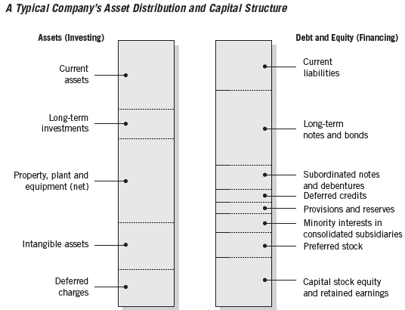

TSPC - Capital Structure KLBF - Capital Structure
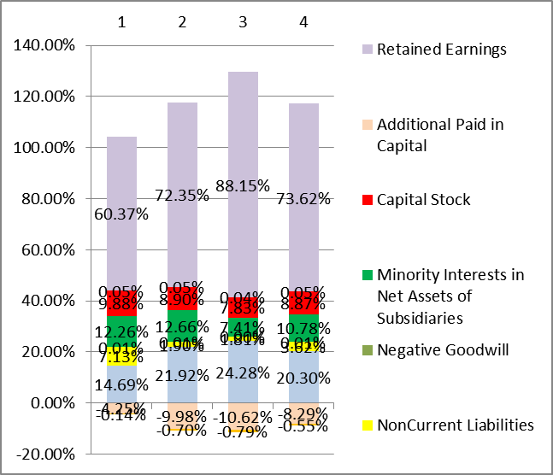
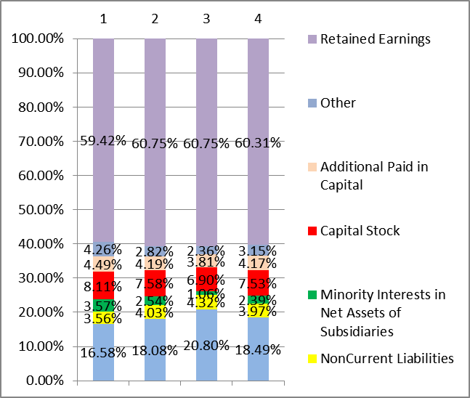

These chart of CapitaL Structure tell us the percentage of the right side of B/S component against Total Assets column 1,2,3 represent year 2007, 2008, and 2009 repectively while column 4 represent the average percentage for those years
We can see clearly that both companeir asseies depends on R/E and C/L to finance their operation. We should note here that C/L for both company dominated by their Trade Payable (appendix). The significance of Trade Payable on capital structure means that those companies have been using short term financial management to enable the arrangement of idle capital which should have been used on paying trade payable, to finance their activities by fully optimizing the due terms of the payables. This prectice however could have some drawbacks, which is the Interest Expense and the dependancy to supplier policy. If for instance the supplier tightened their credit policy, TSPC have to figure out their case and inventory cycle and find another source of financing
These chart also shows as that both companies R/E constitute more than 50% of their Capital Structure, this means that both tend to lean on Equity Financing, and equity financing as we discussed before bear their specific risk, for example the use of Debt Financing would yield lower tax (but also higher interest), or the portion of capital that was retained could have been used to invest on risk free asset or another form of invesment which can yield better than used to finance the company. Or for the extreme example in the case of bankruptcy company can file a plead for protection against creditor to government
However these finding of using R/E extensively could be seen that both companies sees that their industry (pharmacy)is at growing stage, this may be true if we see their Total Assets growth for 2007 – 2008 and 2008 – 2009 which is 6.99 and 9.98 for TSPC and 11.01 and 13.65 for KLBF. When the company is at growing stage they more focused on growing the companies and getting better return, and growing industry are more likely to growth better profit than investing on market considering the market risk, it is only natural that company allocate their resource (R/E) to the thing they understand which is their own companies. A company which has reach the stage where growth over years are diminishing or almost not growing (latent stage) theoretically would want to minimize the cost as they can no loger grow income therefore they aremore likely to use debt financing as it would minimize the burgeoning taxes

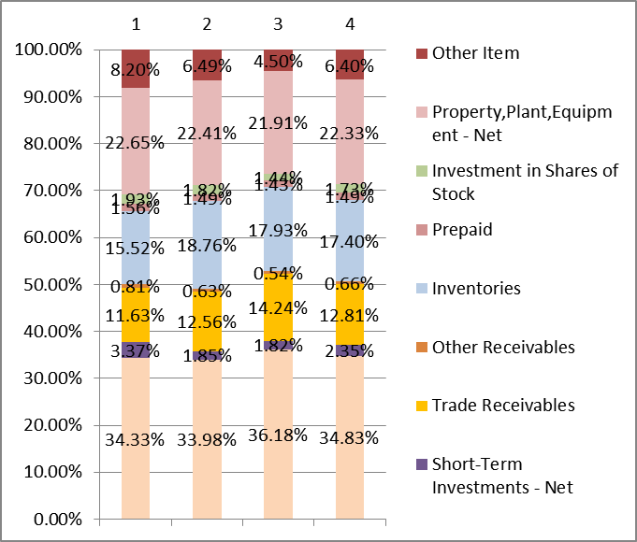
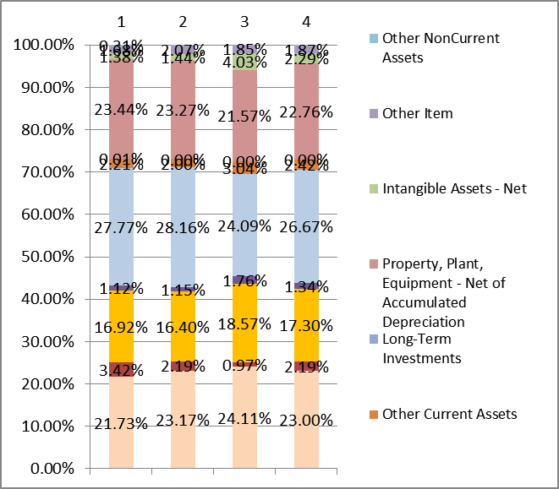
TSPC - Assets Distribution KLBF – Assets Distribution

We can see that for both companies PPE, Inventories, Trade Receivables, and Cash & Cash Equivalents are the components that constitutes most of Assets Distribution PPE are relatively the same, TSPC have lower average for Inventories and Trade Receivables this can be seen that TSPC operate more effectively that KLBF, TSPC also have higher Cash & Cash Equivalents which means higher acid ratio

Solvency Ratios
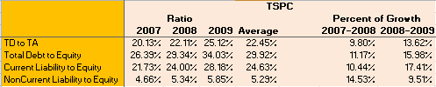

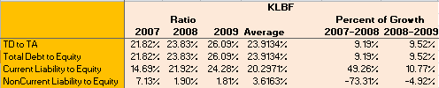

The abovechart shows us TSPC and KLBF solvenc ratios, TD Ratio is relatively the same, while TD to TE and CL to TE is higher on KLBF, the NCL to TE for TSPC is relatively constant while KLBF seemed to have decreasing NCL to TE, this largely due to the of Bonds Payable account which occurred on 2007 but cease to exist in 2008 and 2009

Part II – Earnings Coverage

Now that we have been able to discuss the capital structure measures above, we have to understand that those measure is inable to focus on availability of cash flows to service debt. That’s where Earnings Coverage come to fill in, the role of earnings coverage was meant to measure the ability of company to pay their cost and liabilities
On this paper we creatively adapt on the availability of data to create the Earnings Coverage measure of TSPC, and KLBF
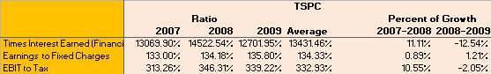

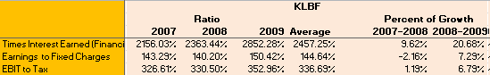

Earning Based Valuation

Valuation, in the simplest meaning is simply the way we price our investation, different people with different emphasis on their investment might use different way to value. However most of valuation have something to do with discounting stream of expected cashflow

Price to Book (PB) Ratio
PB ratio aimed to see the ratio of MV of equity against BV of equity, this valuation can inform us whether the market value has been inflated
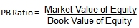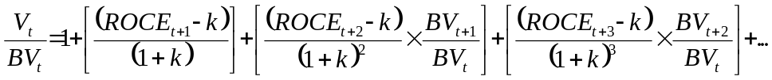

Note:
- ROCE and growth in book value increase → PB increases
- Cost (risk) of equity capital increases → PB decreases
- Present value of future abnormal earnings is positive (negative) → PB is greater (less) than 1.0

Price to Earning Ratio
PE Ratio shows us the MV of equity against NI, this valuation is important for those who aimed te expect some capital gain by receiving dividend or selling the company stock

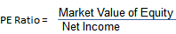

PE ratio can be written as a function of short-term (STG) and long-term growth (LTG) of earning per share (eps) as follows

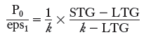
Where k is the cost of equity capital, STG (LTG) is the expected short-term (long-term) % change in eps relative to expected “normal” growth (STG>LTG and LTG>k)
Note:
- The PE ratio is inversely related to k
- The PE ratio is positively related to the expected growth in eps relative to normal growth.

TSPC

 | Ratio |  |  |  | Percent of Growth
 | 2007 | 2008 | 2009 | Average | 07 - 08 | 08 - 09
MV per Share | 632.7 | 376.26 | 730 | 579.6533333 | -68.15% | 48.46%
Shares Outstanding | 4,500,000,000 | 4,500,000,000 | 4,500,000,000 | 4,500,000,000 | 0.00% | 0.00%
MV of equity | 2,847,150,000,000 | 1,693,170,000,000 | 3,285,000,000,000 | 2,608,440,000,000 | -68.15% | 48.46%
BV of equity | 2,115,644,199,183 | 2,235,687,760,131 | 2,408,870,867,823 | 2,253,400,942,379 | 5.37% | 7.19%
NI | 278,357,723,400 | 320,647,898,367 | 359,964,376,338 | 319,656,666,035 | 13.19% | 10.92%
PB Ratio | 1.3458 | 0.7573 | 1.3637 | 1.1556 | -77.70% | 44.46%
PE Ratio | 10.2284 | 5.2805 | 9.1259 | 8.2116 | -93.70% | 42.14%

KLBF
 | Ratio |  |  |  | Percent of Growth
 | 2007 | 2008 | 2009 | Average | 07 - 08 | 08 - 09
MV per Share | 1219 | 392 | 1305 | 972 | -211.06% | 69.99%
Shares Outstanding | 10,089,999,578 | 9,755,320,697 | 9,577,217,406 | 9,807,512,560 | -3.43% | -1.86%
MV of equity | 12,295,269,885,768 | 3,821,549,329,843 | 12,502,961,551,359 | 9,539,926,922,323 | -221.74% | 69.43%
BV of equity | 3,386,861,941,228 | 3,622,399,153,499 | 4,310,437,877,062 | 3,773,232,990,596 | 6.50% | 15.96%
NI | 705,694,196,679 | 706,822,146,190 | 929,003,740,338 | 780,506,694,402 | 0.16% | 23.92%
PB Ratio | 3.6303 | 1.0550 | 2.9006 | 2.5286 | -244.11% | 63.63%
PE Ratio | 17.4229 | 5.4067 | 13.4585 | 12.0960 | -222.25% | 59.83%

Both companies experience downturn on PB and PE Ratio on 2008 this is attributed to American Mortgage Crisis, we can see very clearly that the change is attributed to the company MV per share which significantly lower on 2008.

Generally KLBF had higher PB and PE Ratio than TSPC, however this is expected since they had bigger equity than TSPC, this seemingly higher ratio also could be seen as a sign that KLBF was seen as a better known company.
Summary
Generally we can say that KLBF is more like a well established company with its operations, while TSPC is a smaller yet more effective company. KLBF and TSPC has different strategies to pursue, KLBF has a grip on domestic market (Indonesia) while TSPC is agressively expanding on overseas market.

